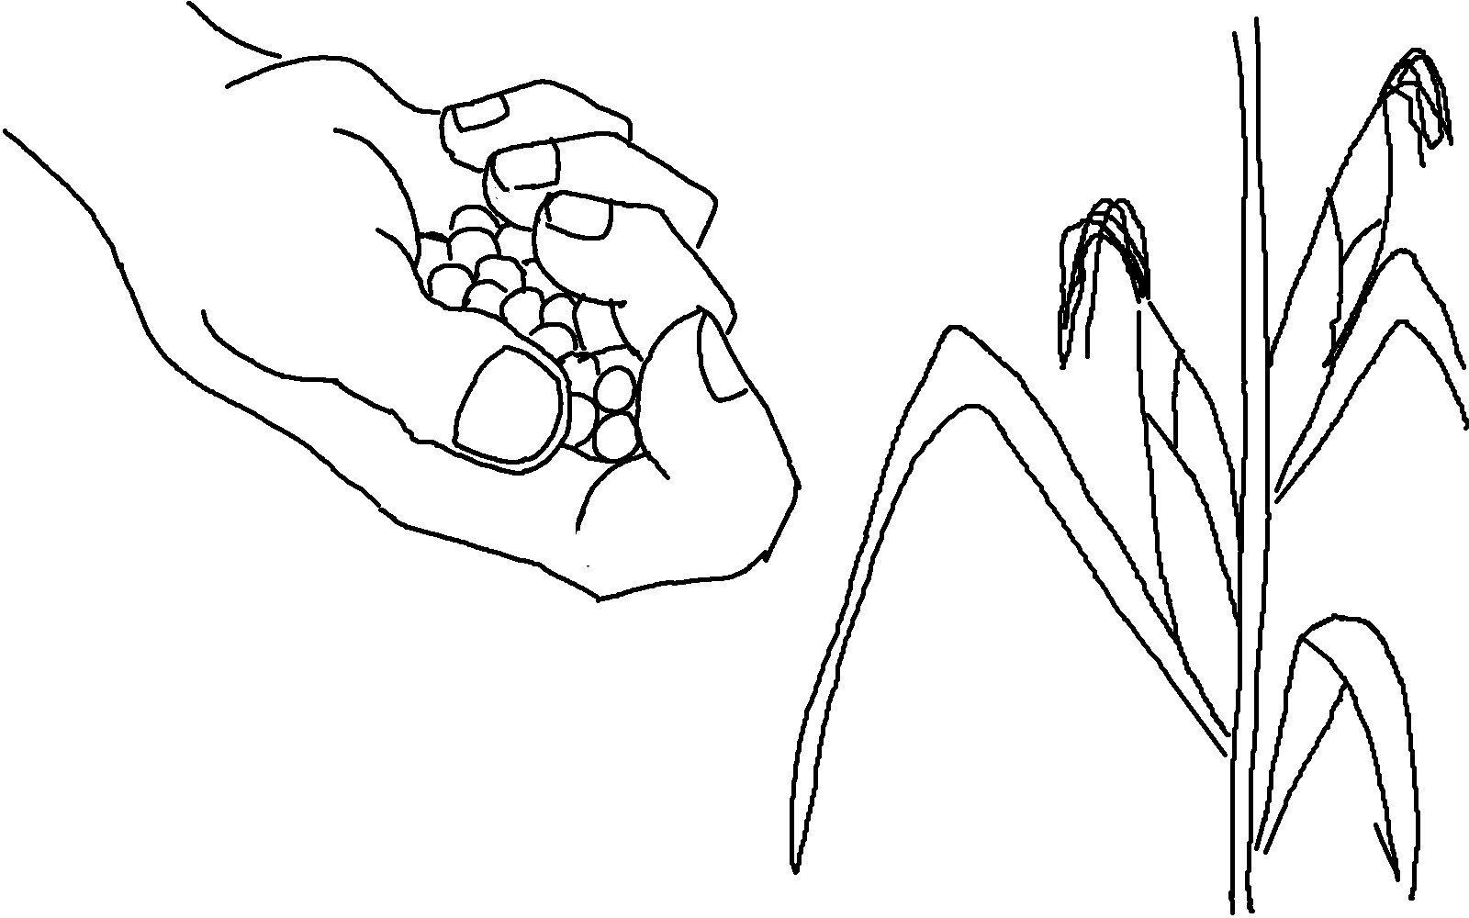

You will always harvest what you plant.
Galatians 6:7 _{NLT}

